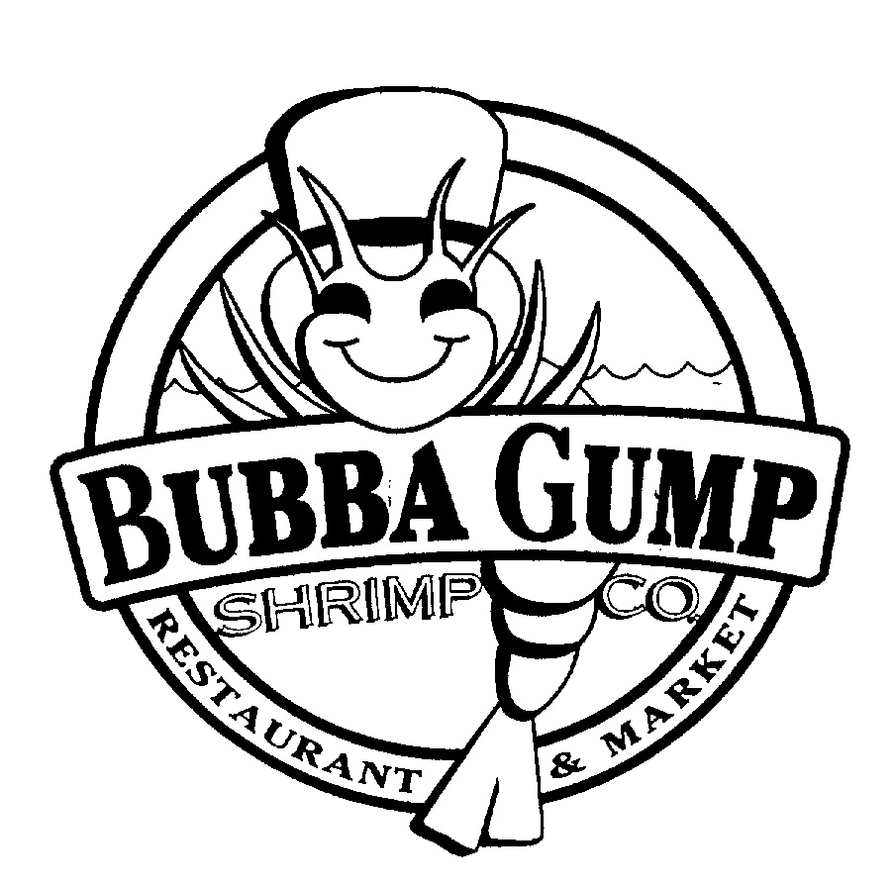

Directions: Over the next few days we will be watching the film Forrest Gump starring Tom Hanks. This film touches on many of America’s major events including Vietnam and the Counterculture movement. Below are questions that you will answer as you watch the film. They do not need to be in complete sentences.

- Where did Forrest place the feather he found at the beginning of the movie? |  | 11. Who were the two black students enrolled at the University?
- Forrest’s legs were as strong as the doctor has ever seen but his back was as crooked as what? |  | 12. Who does Jenny dream to be famous like?
- Where did Forrest live? |  | 13. Who was president when Forrest was on the All-American Football Team
- What is Forrest’s IQ? What is state minimum for attending state schools? |  | 14. What famous actress had her picture in the White House bathroom?
- Who was the person staying with the Gump’s who had a guitar? |  | 15. What town was JFK in when he was shot?
- Why didn’t Jenny ever want to go home? |  | 16. Who was his little brother? What happened to his little brother?
- Why did Forrest feel Jenny was afraid to stay with her Grandma? |  | 17. What did the sergeant want to nominate Gump for if it wasn’t a waste of a good enlisted man?
- Who was the coach doing the scouting at the practice as Forrest ran through? |  | 18. Why did Jenny get in trouble at her college?
- What school did Forrest play football for? |  | 19. Who was Jenny introduced as at her new signing job?
- Who carried out the threat to stand in front of the school house doors preventing the black students from entering? |  | 20. What dream did Jenny accomplish, according to Forrest?
21. Who was singing the song while Forrest flew into Vietnam? |  | 33. Where is the bus heading to when Jenny leaves DC?
22. Why are Forrest and Bubba not to salute their lieutenant? |  | 34. Who was Who was a guest on the same TV talk show Forrest was on?
23. What were the two standing orders of Forrest’s platoon? |  | 35. Who was hosting the TV Christmas special at Lt. Dan’s?
24. Who were they always looking for on their long walks? |  | 36. Who was president when the US Ping Pong Team visited the White House?
25. What had Jenny become while Forrest was in Vietnam? |  | 37. What hotel had “problems” when Forrest called to complain about flashlights?
26. What is the air strike going to drop close to Forrest’s platoon? |  | 38. What destroyed everything in its path, including all shrimp boats EXCEPT Forrest’s?
27. Where was the hospital Forrest was in? |  | 39. What president avoided assassination?
28. What group performed while Forrest was playing ping pong by himself? |  | 40. The Bubba-Gump Shrimp Company would take care of Forrest’s money by investing with whom?
29. What award did Forrest win? |  | 41. What president is shot in the chest?
30. Who awarded his medal and escalated the war in Vietnam? |  | 42. What disease does Jenny have?
31. Why were the streets so crowded in DC, who were they? |  | 43. What substance are lieutenant Dan’s legs made out of?
32. Where is the protest stage located?

